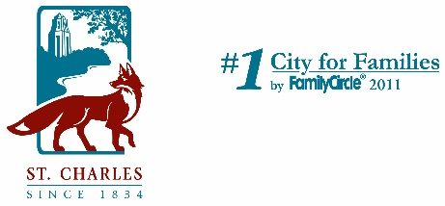­­



March 13, 2020

**Subject: 2nd Avenue and Delnor Avenue – Construction Notification**

Dear Resident:

The City of St. Charles Public Works Engineering Division is pleased to inform you that infrastructure improvements are planned for your neighborhood. Construction is being planned for 2020, which will incorporate replacement of the water main, sanitary sewer, storm sewer improvements and reconstruction of the roadway.

**Project History and Need**

When the City identifies potential streets to be rehabilitated, the underlying utilities are videotaped and inspected for defects/repairs. The existing sanitary sewer along 2nd and Delnor Avenues was found to be in poor condition, with sections of pipe at risk of failure.

When reconstructing a roadway, it is prudent to determine if the remaining life of the existing utilities will outlast the expected life cycle of the new roadway. Staff have determined that the aging watermain and storm sewer facilities are to be replaced at the same time to minimize risk of utility replacement underneath a new pavement.

**Project Information**

In an effort to minimize disruption to the neighborhood, construction will be utilizing trenchless technologies to replace the sanitary sewer and watermain. Trenchless construction methods allow the roadway to remain partially open to traffic during construction, minimizing roadway and driveway closures.

Construction is anticipated to begin in May, with substantial completion by the end of September.

**Resident Informational Meeting**

The City is hosting an informational meeting on **Tuesday, April 14th at 6:00 PM** in the Council Chambers at City Hall, 2 E. Main Street. Residents will have a chance to ask questions, see design plans and hear additional project details such as:

* Construction schedule.
* City contact during construction.
* Property access during construction.

Should you have any immediate concerns or if you cannot attend the meeting and would like to hear further details, please contact me directly at (630) 377-4418 or [kjay@stcharlesil.gov](mailto:kjay@stcharlesil.gov). I am available to discuss the project over the phone or in person if desired.

Sincerely,

cid:image001.png@01D2B46A.FE32C980

Ken Jay, P.E.

Public Works Manager - Engineering